**PORTFOLIO**

ASSIGNMENT OF CSE111

(ORIENTATION TO COMPUTING-1)

**COMPUTER SCIENCE AND ENGINEERING**

Submitted by:

Name: Nitika

Registration number: 12219894

Roll No.: A20

Section: KOC30

**Submitted to :**

**Ramanpreet Kaur**



**LOVELY PROFESSIONAL UNIVERSITY**

**DECLARATION**

I, Nitika, a student of Bachelor of Technology under CSE discipline at Lovely Professional University, Punjab, hereby declare that all the information furnished in this project report is based on my own work and is genuine

NITIKA

Registrartion Number: 12219894

|  |  |  |
| --- | --- | --- |
| Platforms for profile creation | Link to student profile | Screenshot |
| ***Figma*** | Since internal profile doesn’t work, so I am attaching project link  Project1:  <https://www.figma.com/file/LsX6JHrpwYpNdJsEeLzEjw/logo-1?node-id=0%3A1&t=wzsAkkvr0BAZZQLC-1> | 1 |
| ***Quora*** | <https://www.quora.com/profile/Nitika-Kalra-11> | 2 |
| ***Stack overflow*** | <https://stackoverflow.com/users/20933881/nitika> | 3 |
| ***Hacker Rank*** | <https://www.hackerrank.com/nitikakalra2003> | 4 |
| ***Hacker Earth*** | <https://www.hackerearth.com/@nitika146> | 5-6 |
| ***Geeks for Geeks*** | <https://auth.geeksforgeeks.org/user/nitikakaggz3/practice> | 7 |
| ***Github*** | <https://github.com/nitikakalra> | 8 |
| ***Git*** |  | 9 |
| ***CV*** | <https://docs.google.com/document/d/1Sz7plEAZMLnLDs8kGDTuEyq3WqEWgBTH/edit> | 10 |
| ***MOOCS*** | 1.  <https://www.cipherschools.com/videopage?courseid=618a5d12d64fed0023216620&video=19>  2.  <https://www.mygreatlearning.com/academy/learn-for-free/courses/python-fundamentals-for-beginners> | 11 |

FIGMA

Profile:

Figma internal profile with project

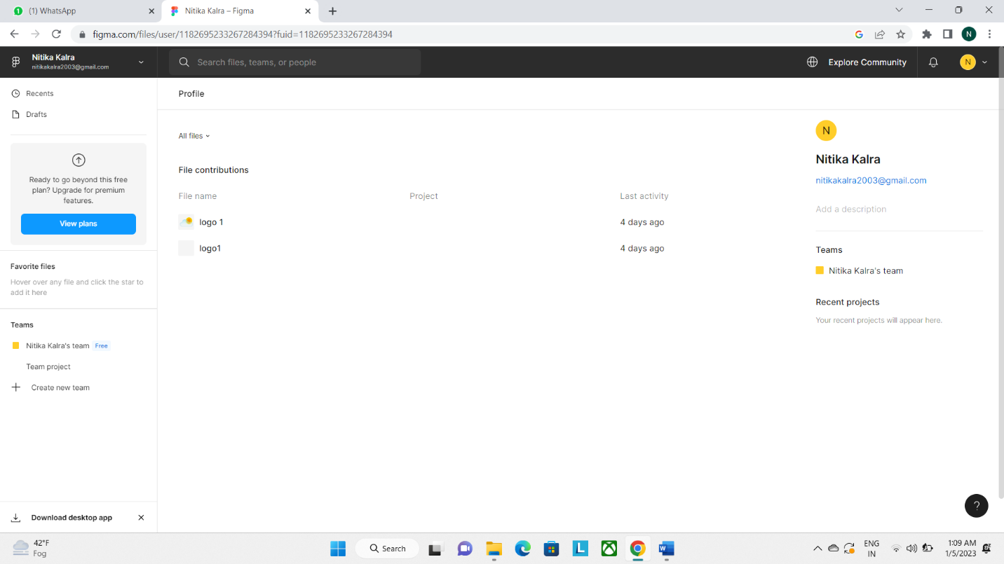

Accomplishment:

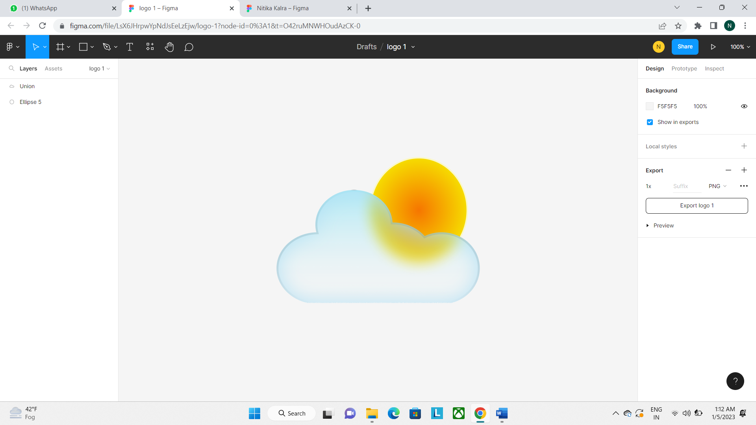

1

QUORA

PROFILE AND ACCOMPLISHMENT:

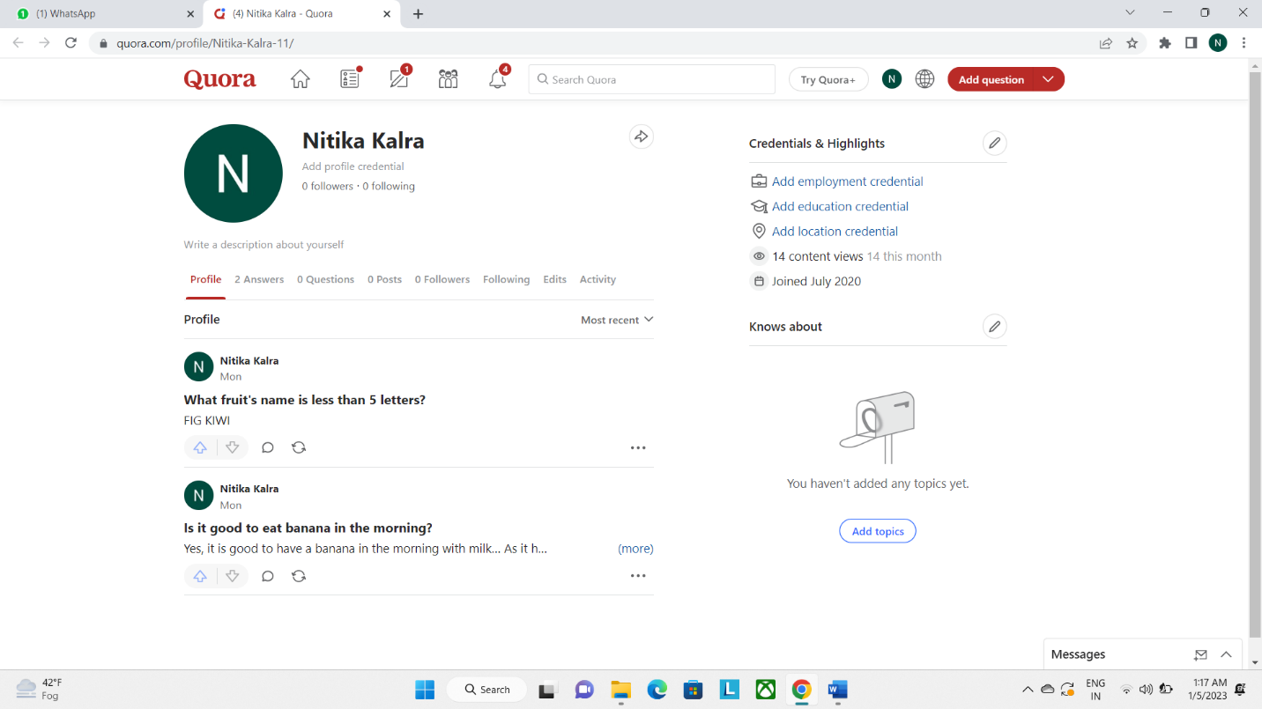

2

STACKOVERFLOW

PROFILE:

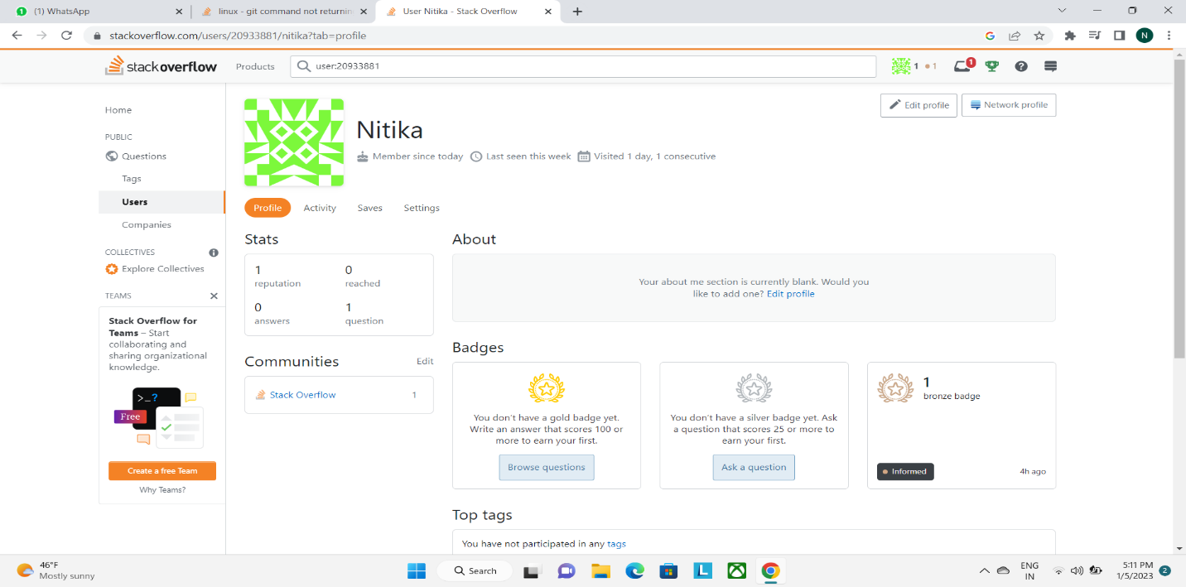

Accomplishment:

Raised a question and got a badge

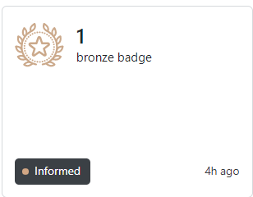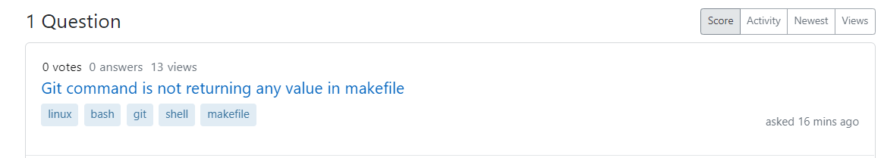3

**HACKER RANK**

**Profile:**

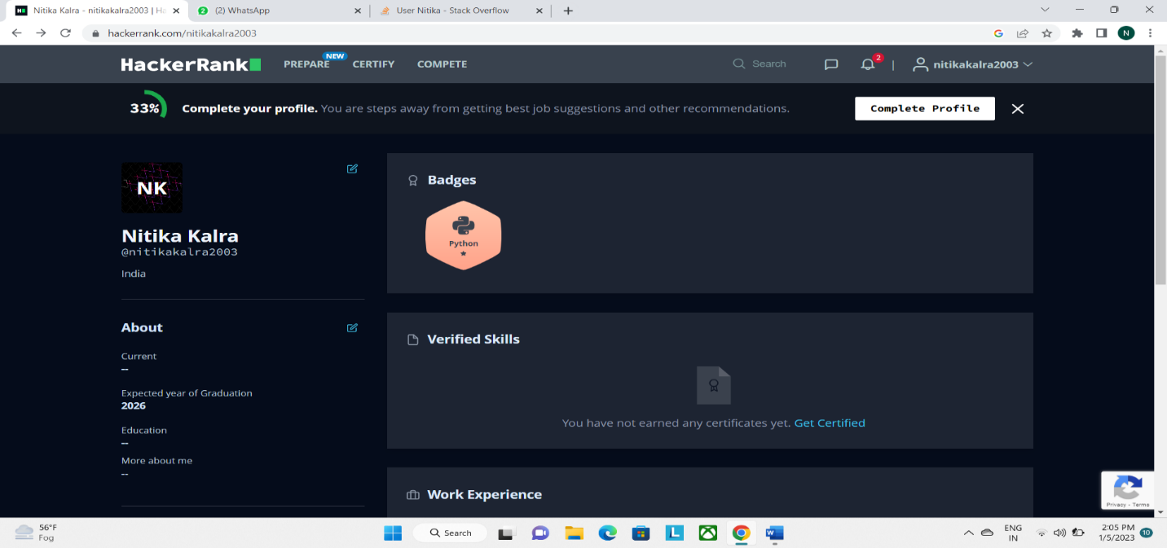

**Accomplishment:**

**Achieved a five star badge in python by solving question.**

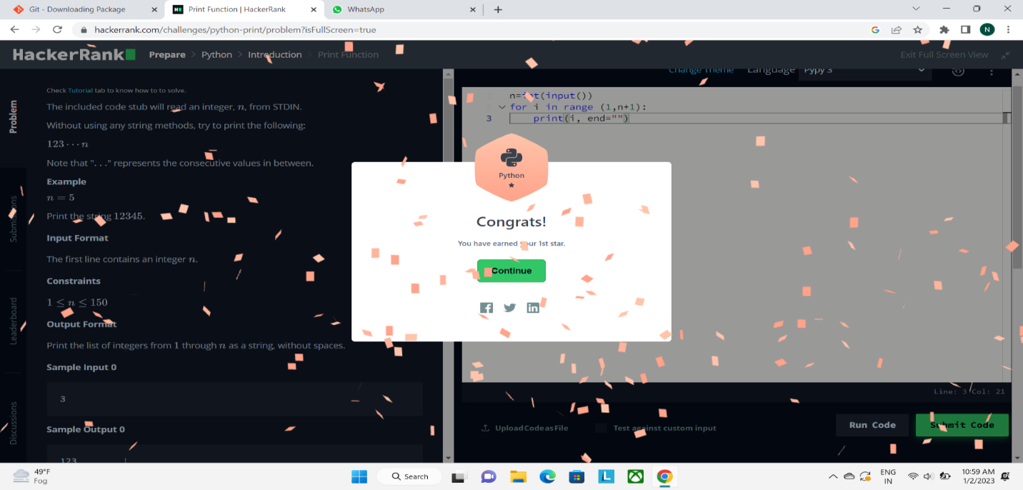

**4**

**HACKER EARTH**

**Profile:**

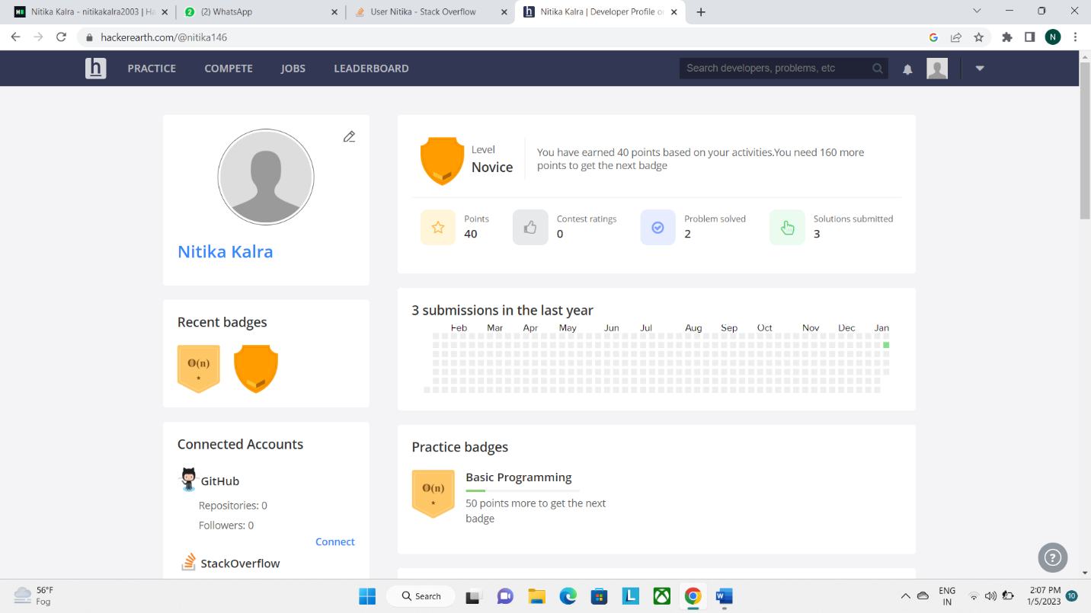

**5**

**Accomplishment:**

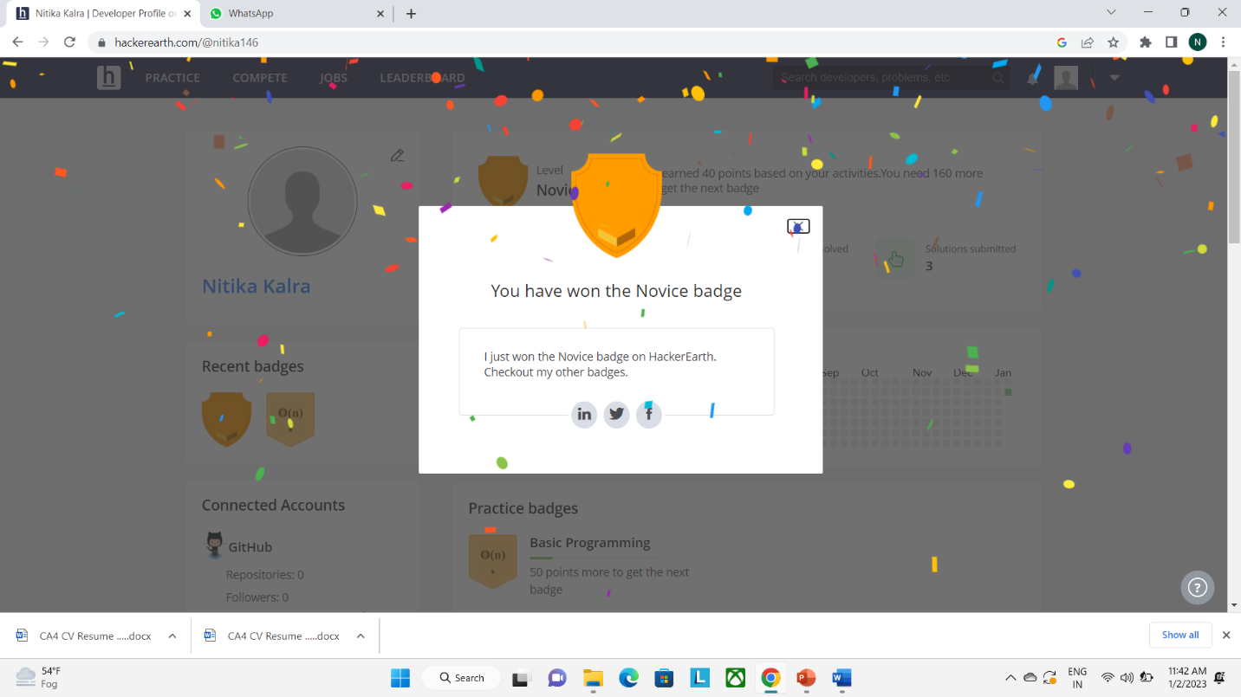

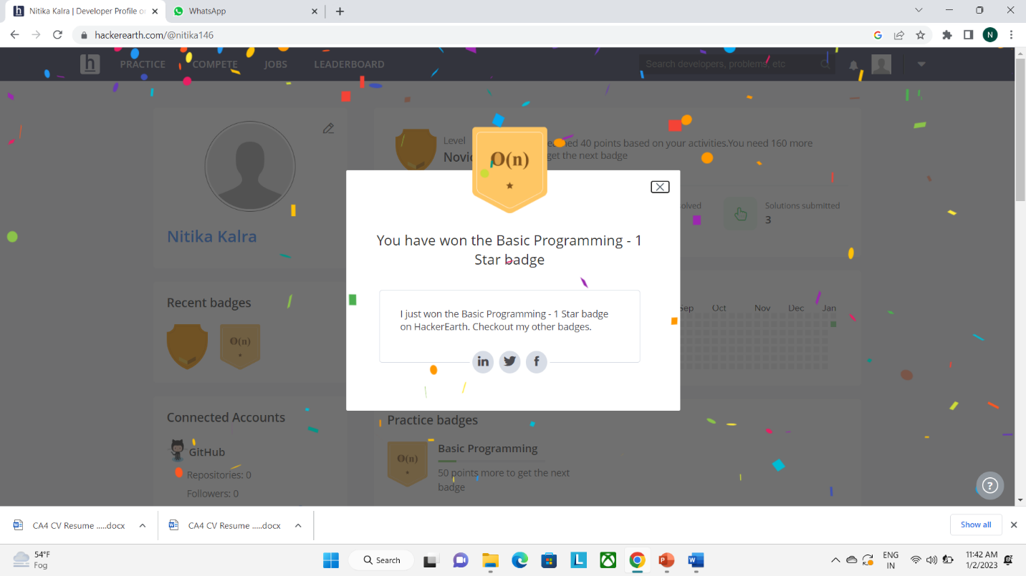

**6**

**GEEKS FOR GEEKS**

**Profile:**

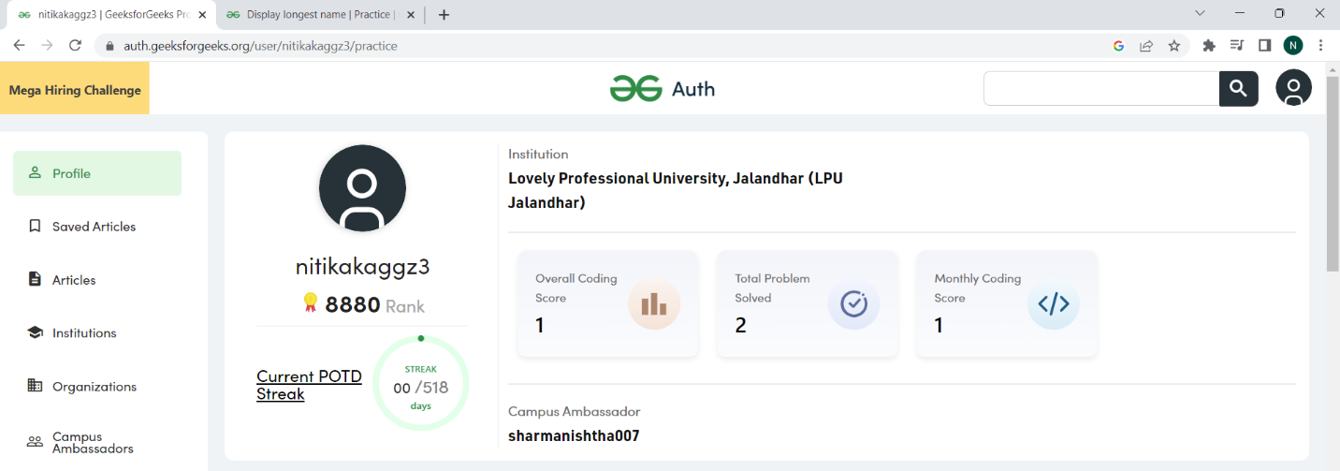

**7**

**GITHUB**

**Profile:**

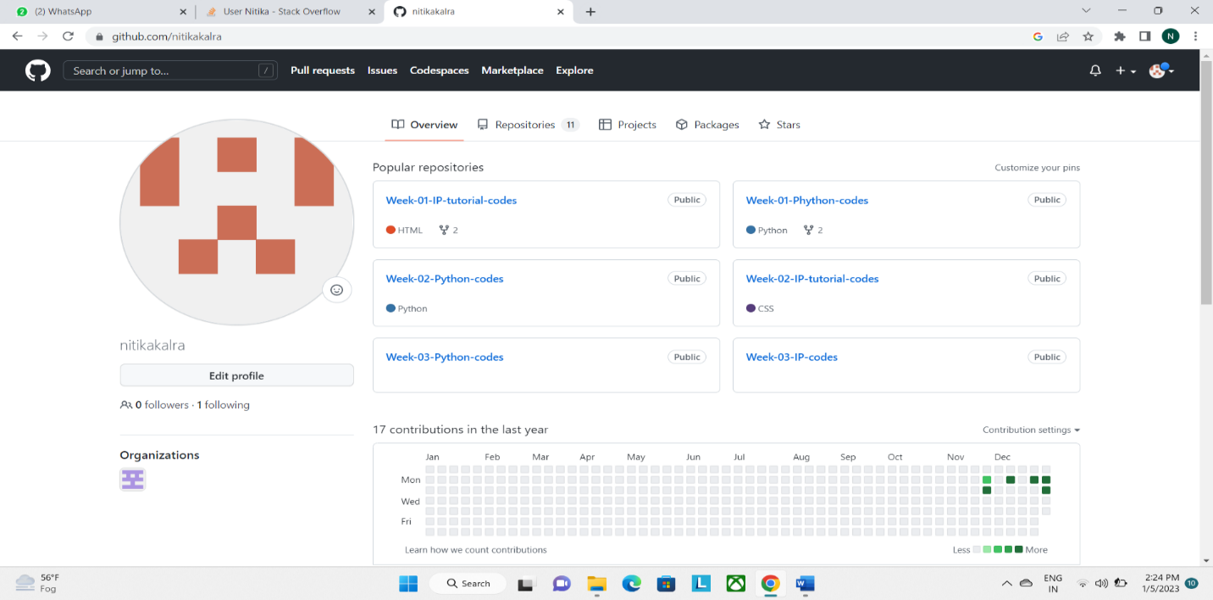

**Accomplishment:**

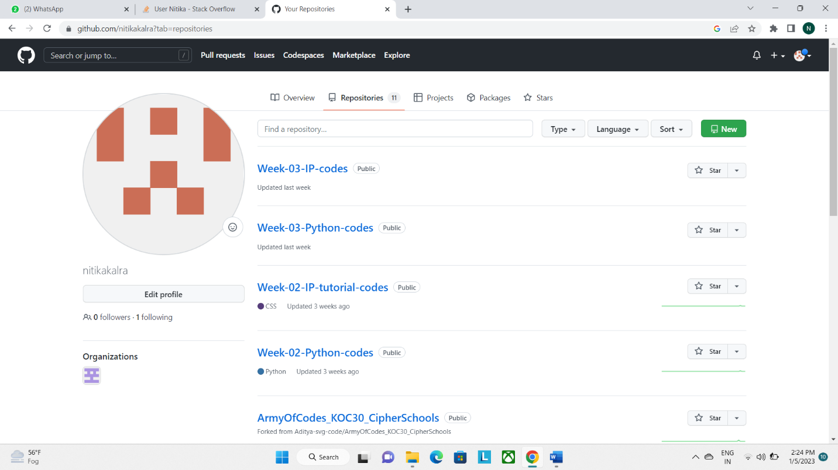

**8**

**GIT**

**Accomplishment:**

**Created a repository and commited a file a in it .**

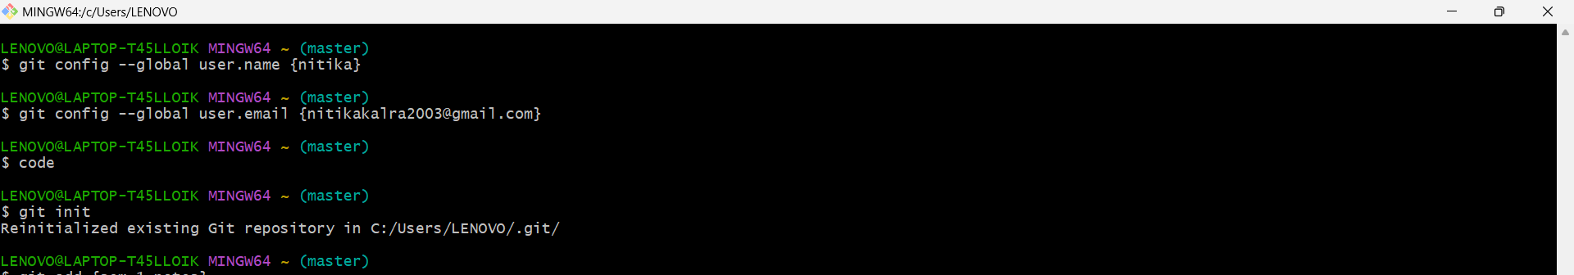

**9**

**CV**

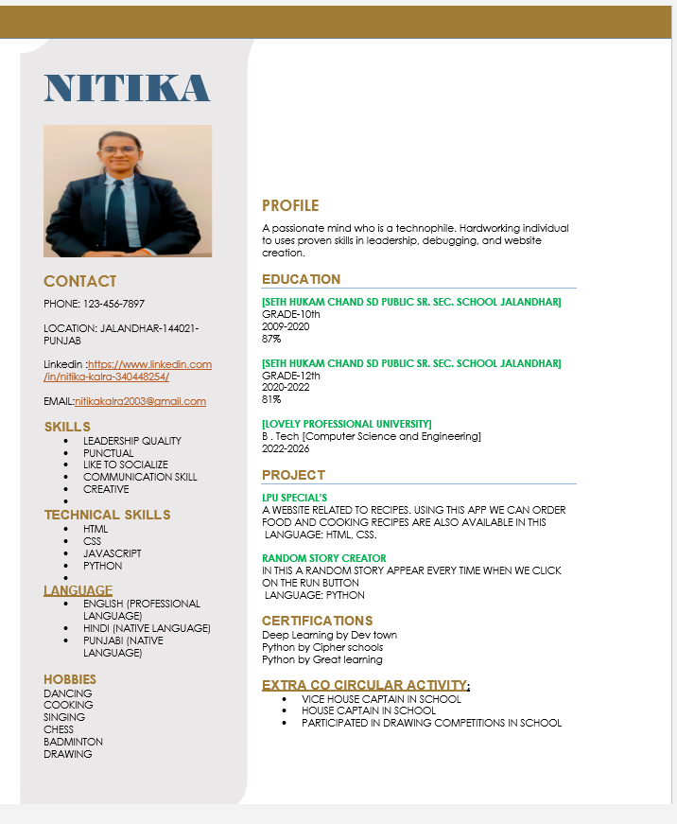

**10**

**MOOCS**

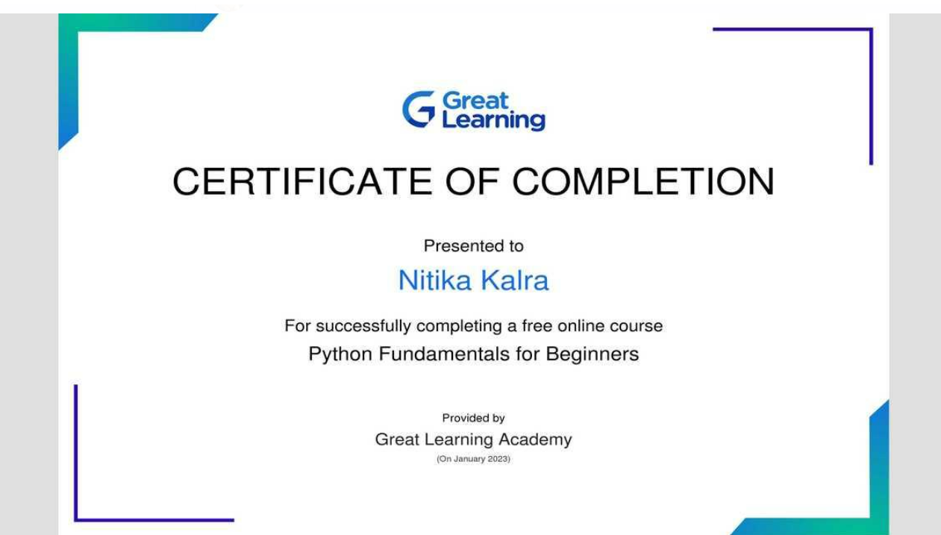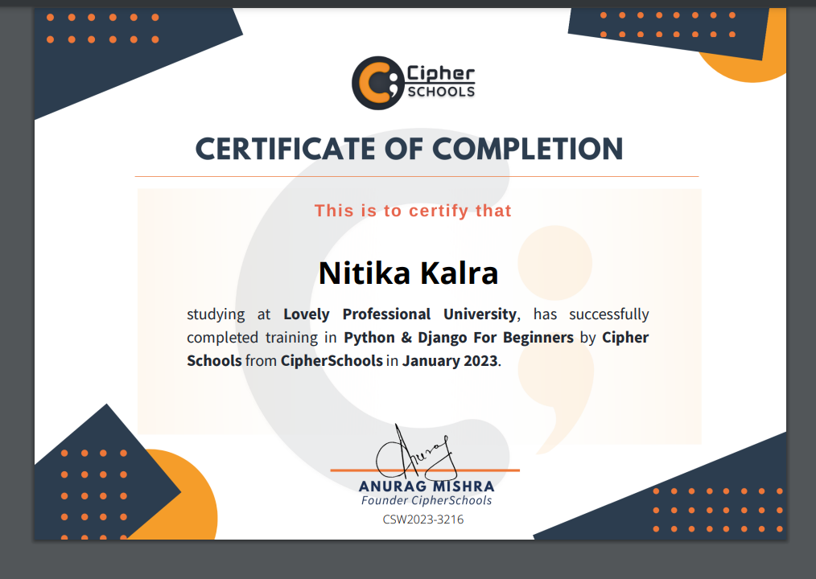**11**